Minor Issue Apps

More examples can be found in our artifact：

<https://drive.google.com/file/d/17UAWrJkfQaI_rkepJNHZthRMxOeYhRxN/view?usp=sharing>

6 - Age Calculator

6 - Age Calculator : https://github.com/Pawansharma08/AgeCal/tree/f289770d9e07dccfeb7a2a9790a43fa8f87ab77f

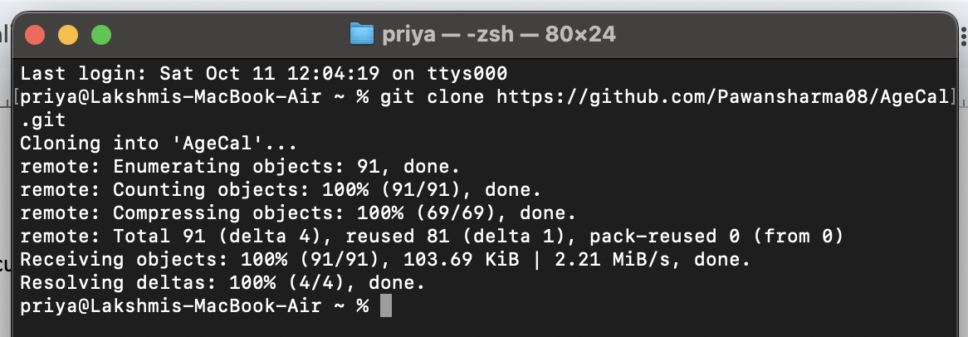

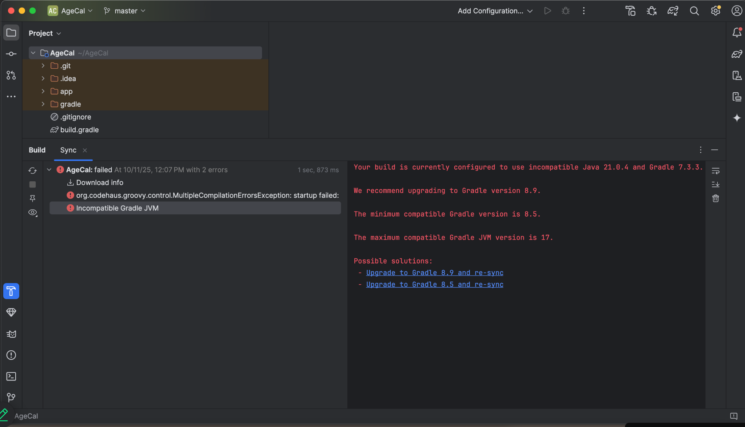

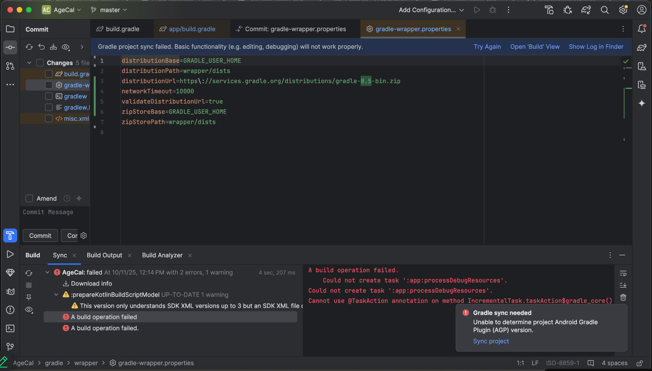

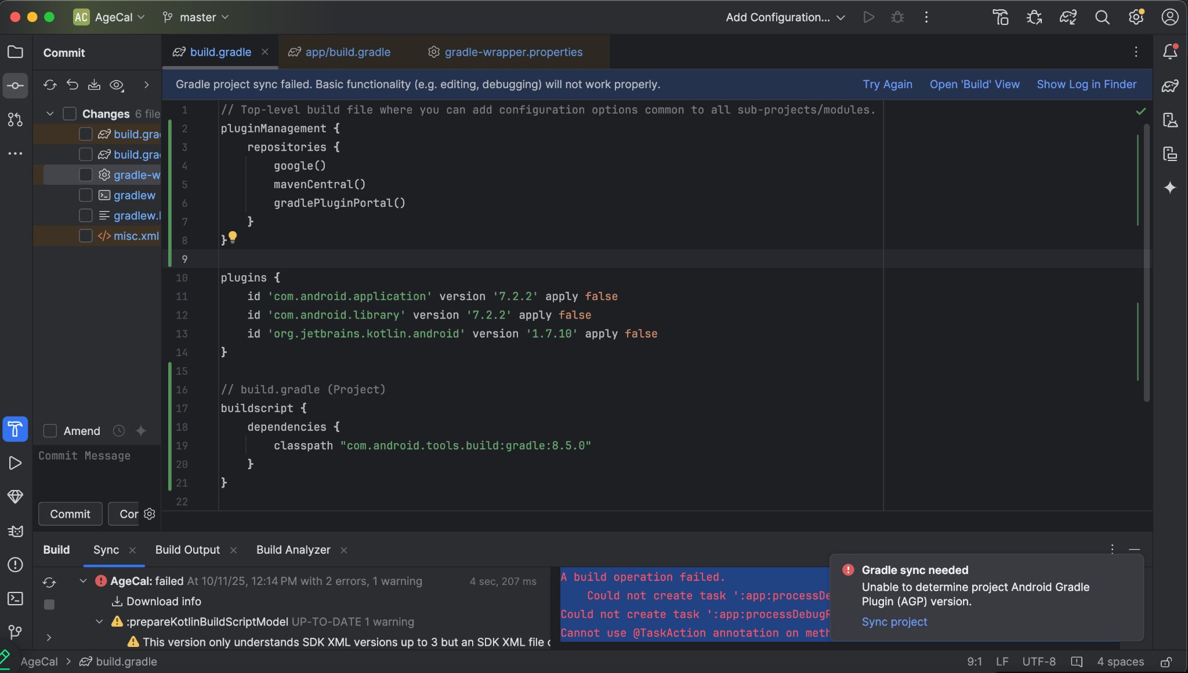

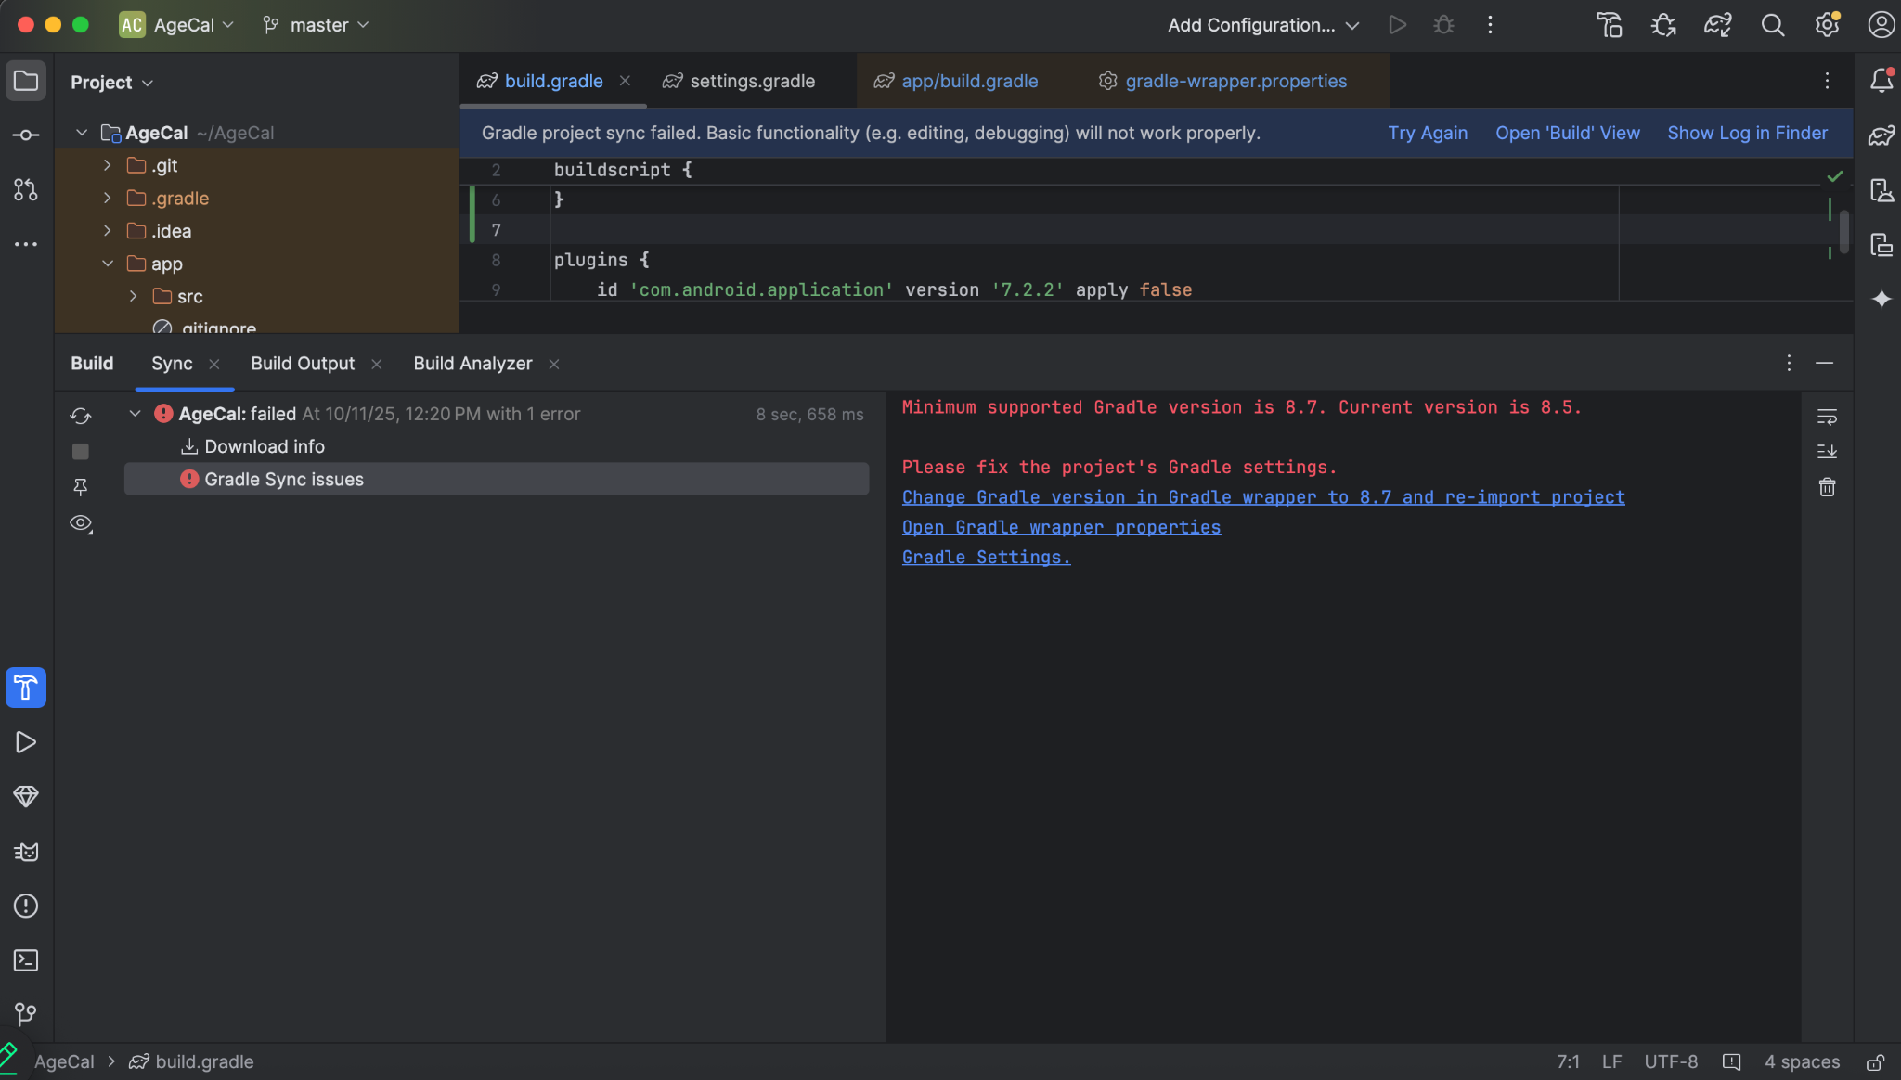

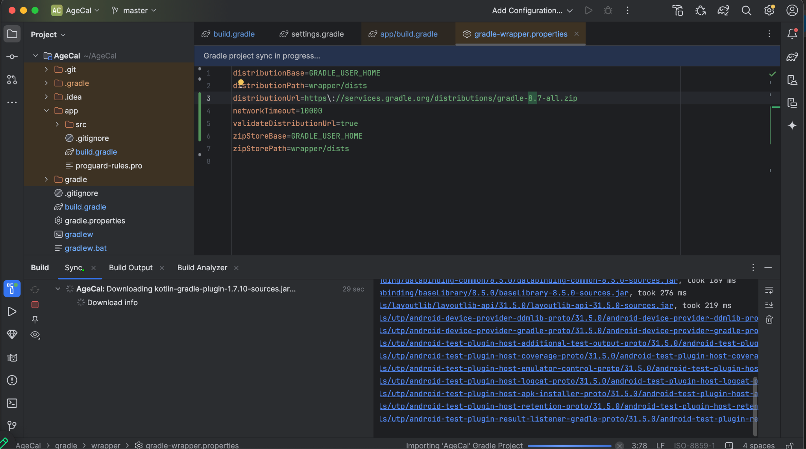

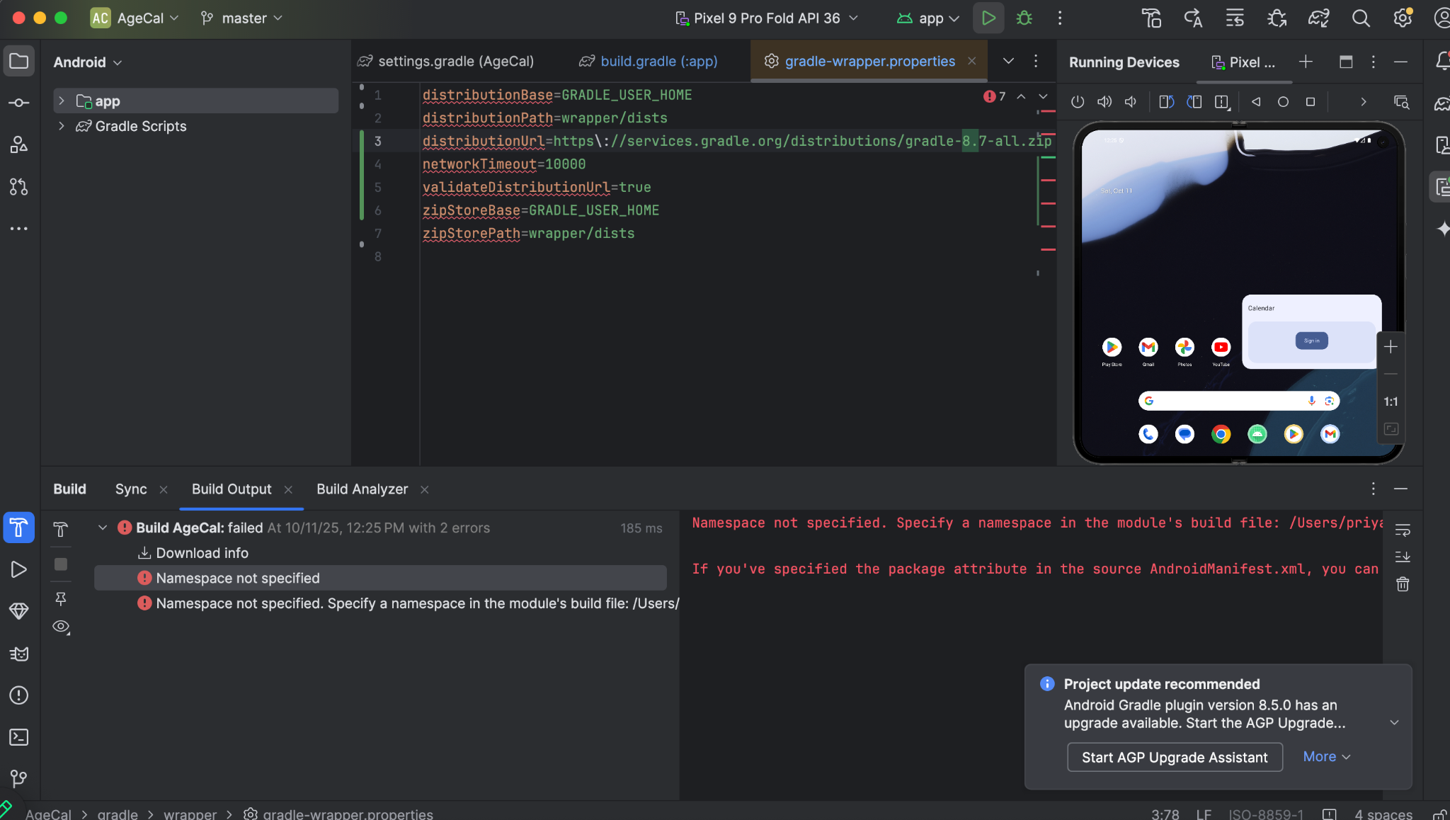

Complied Successfully

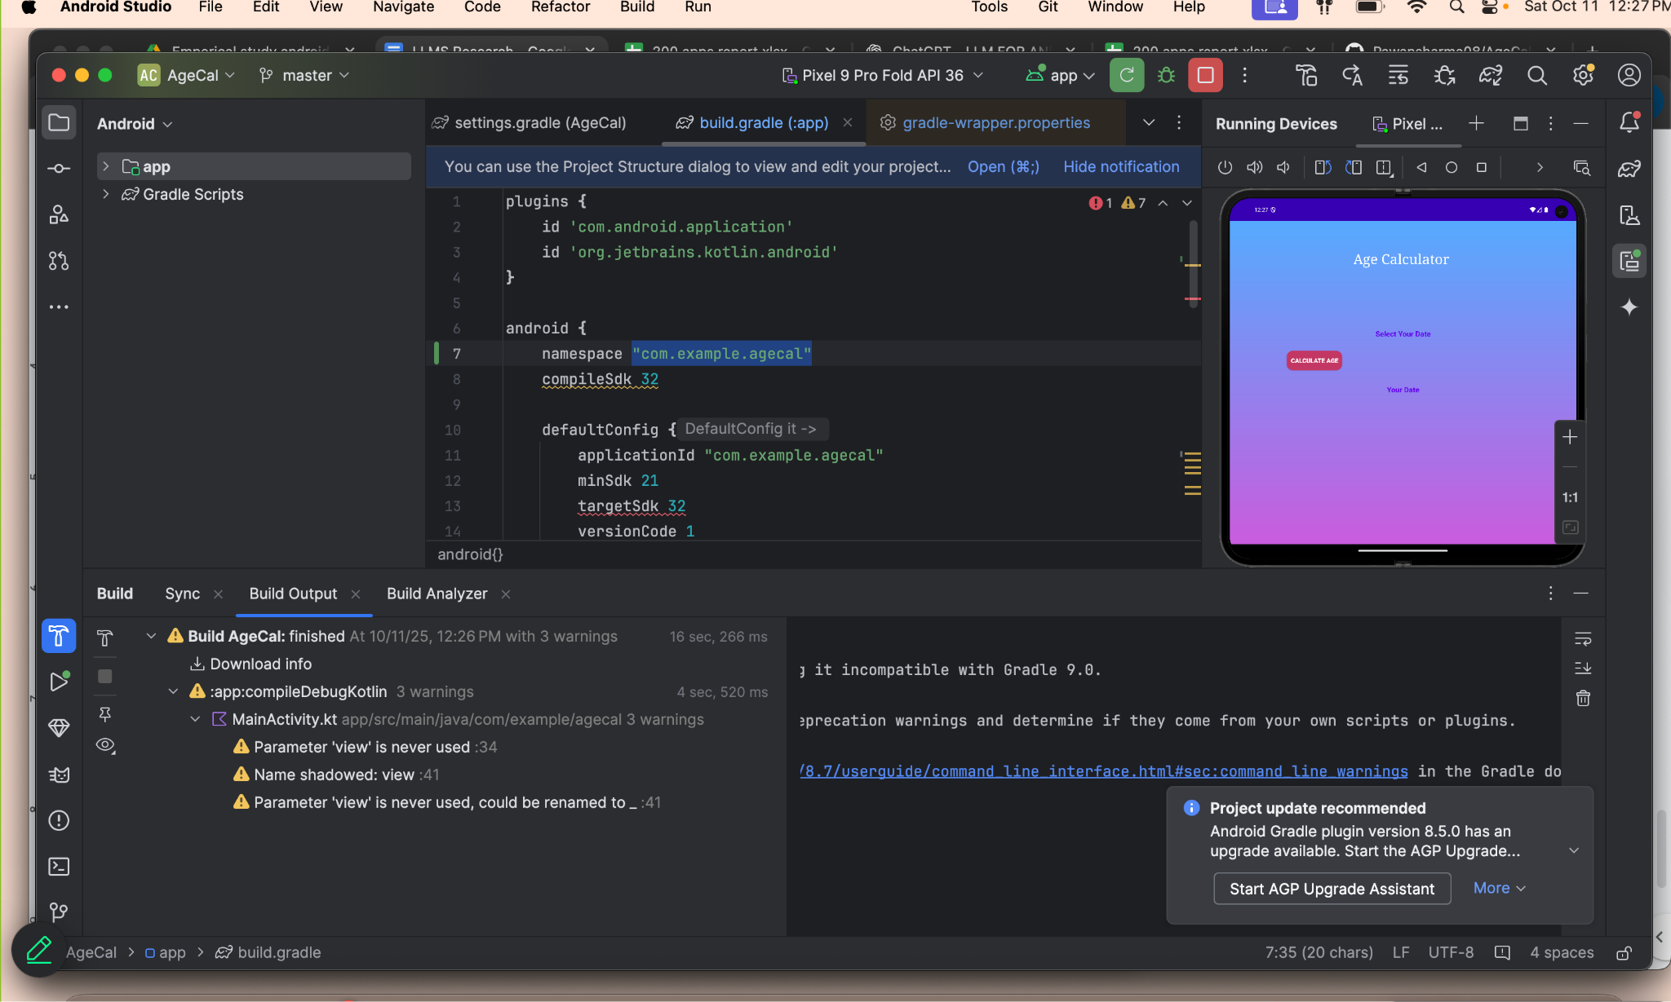

Running Successfully

Chat GPT link : <https://chatgpt.com/share/68ea85a5-7990-8009-bcff-26ee4a5b8248>

Major Issue Apps

24 – CalculatorApp

Major issue

24 - CalculatorApp

<https://github.com/anubhavshrimal/CalculatorApp/tree/b36c1ccc4602e8c260253c35cecf1921df73baa6>

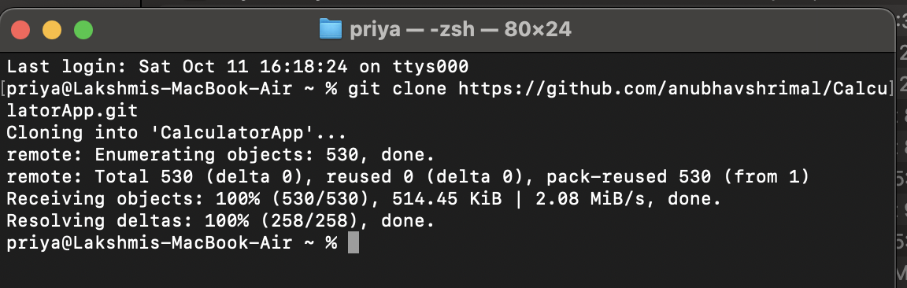

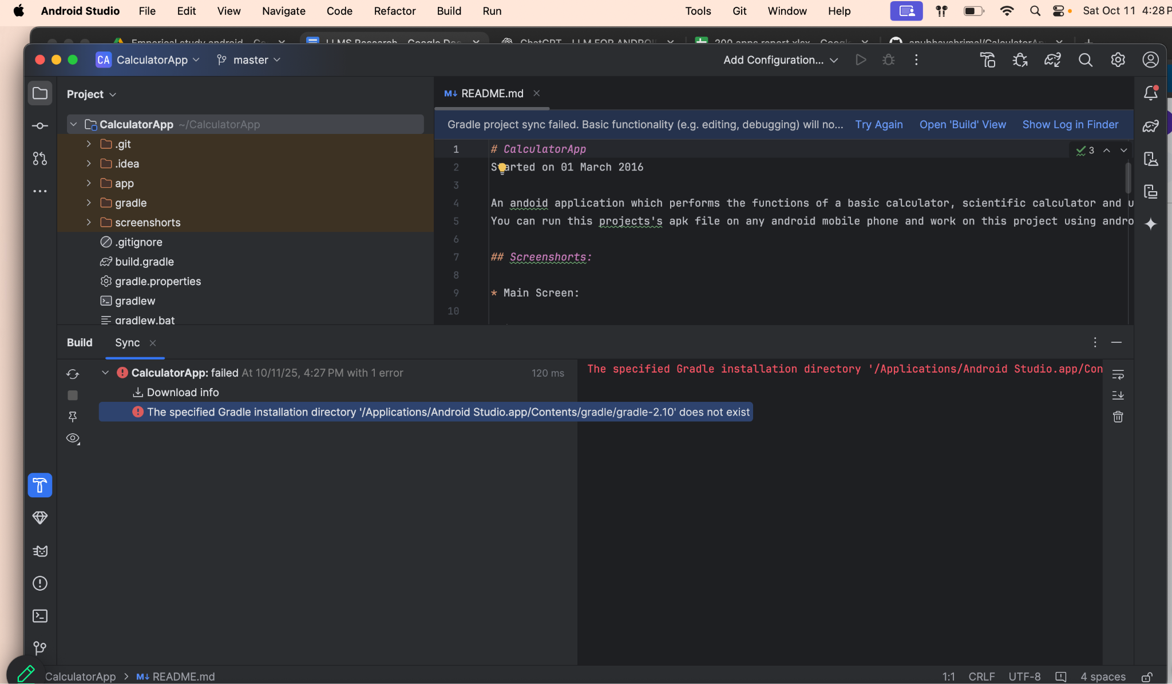

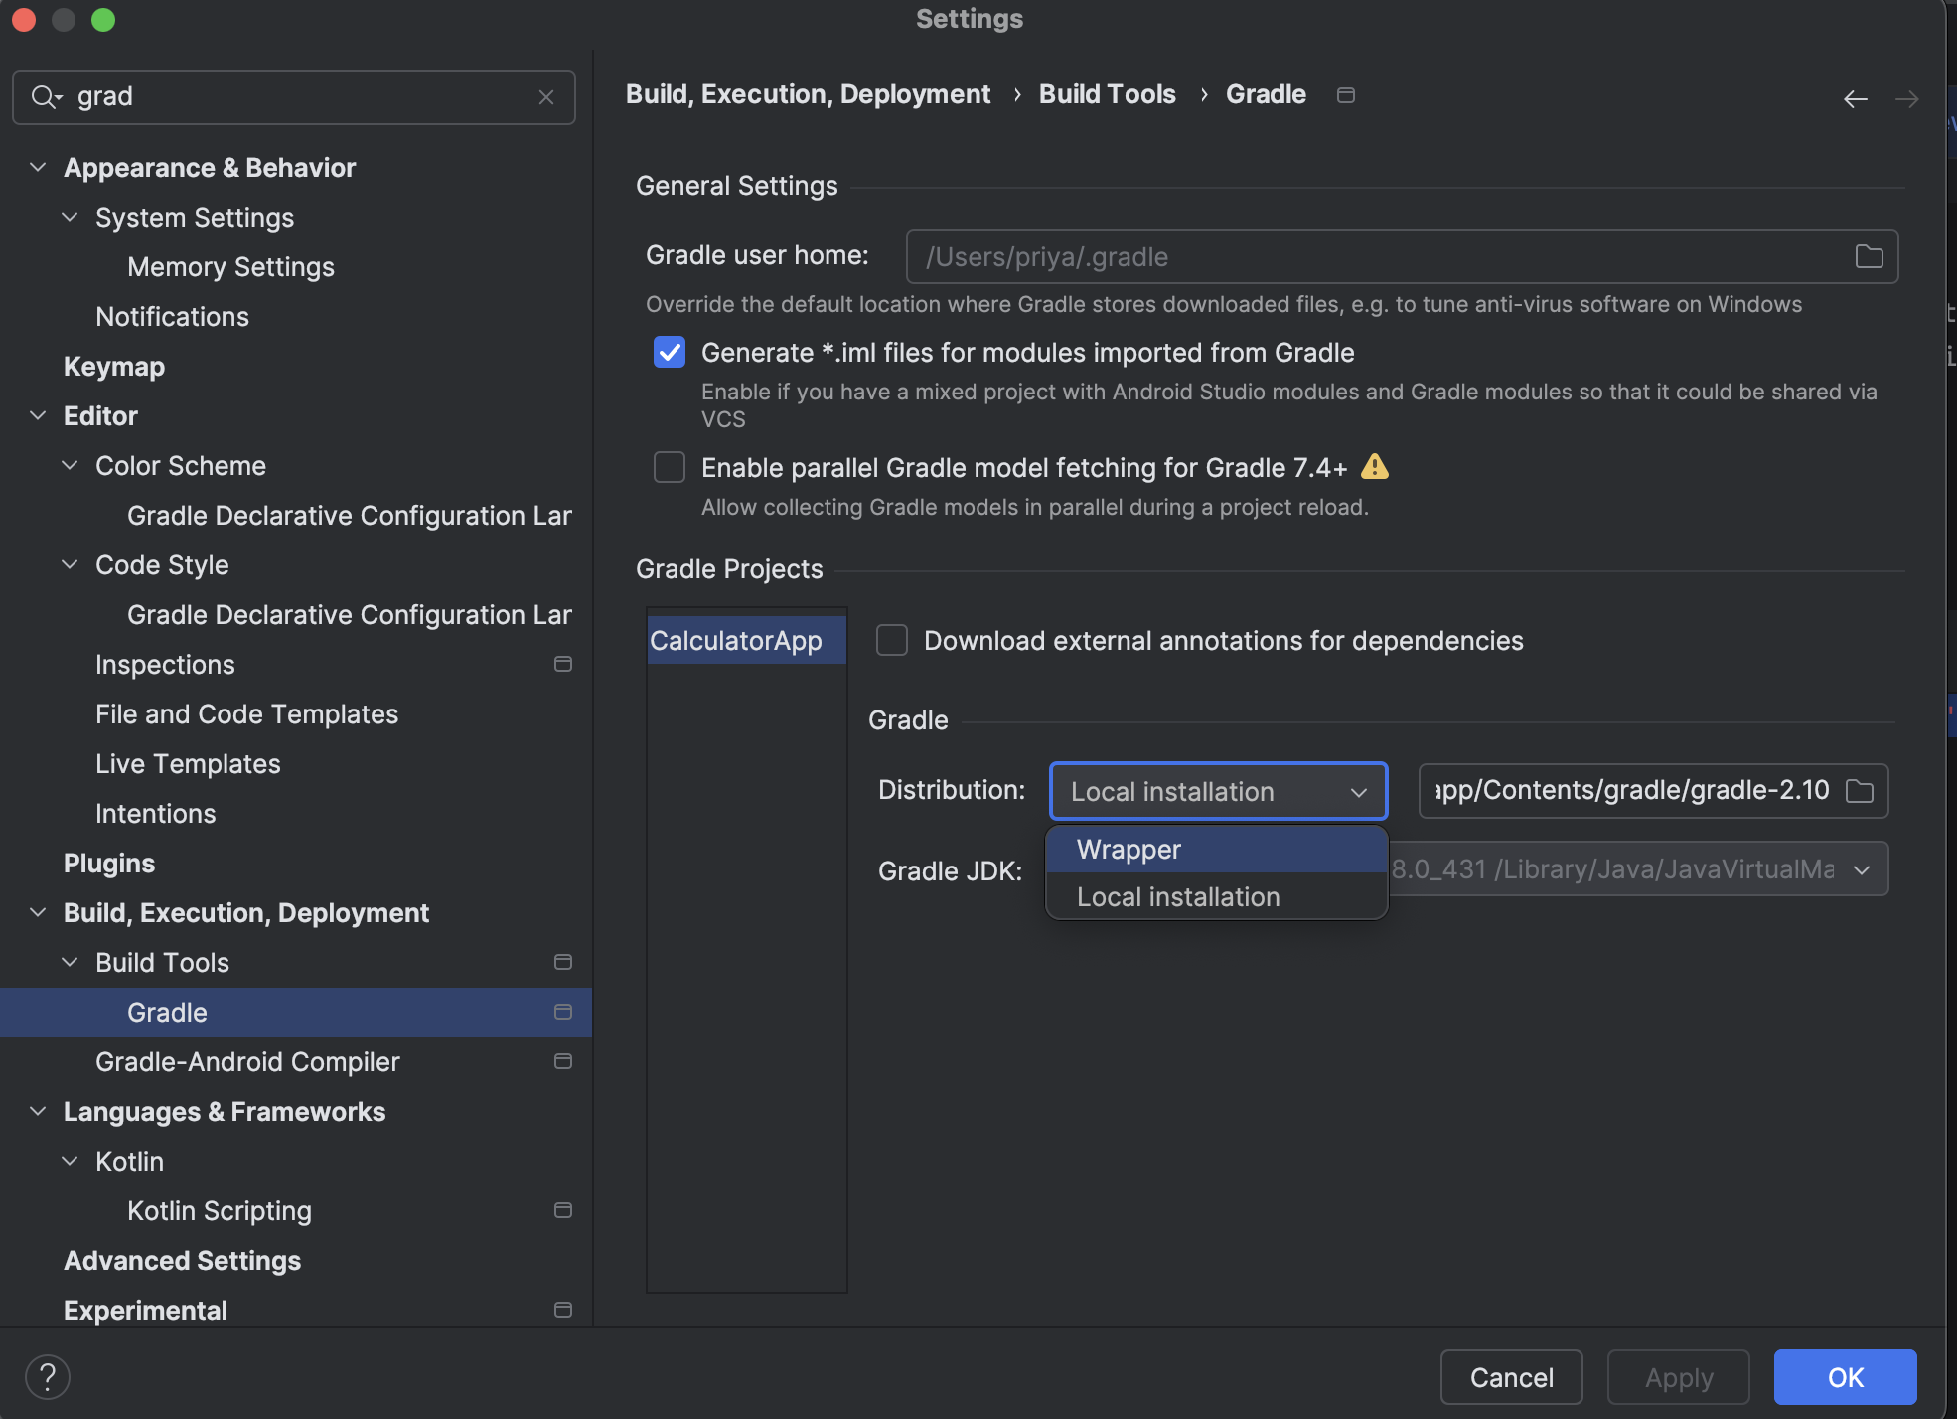

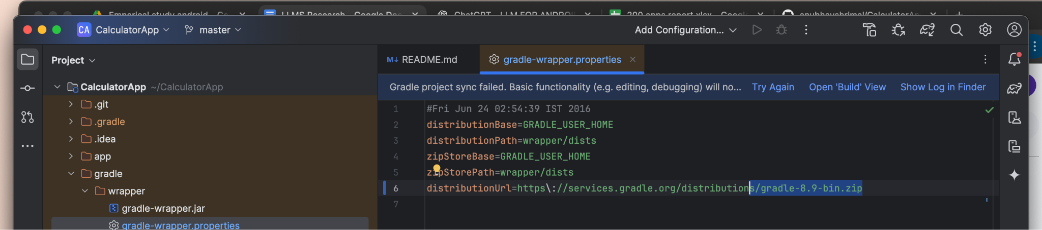

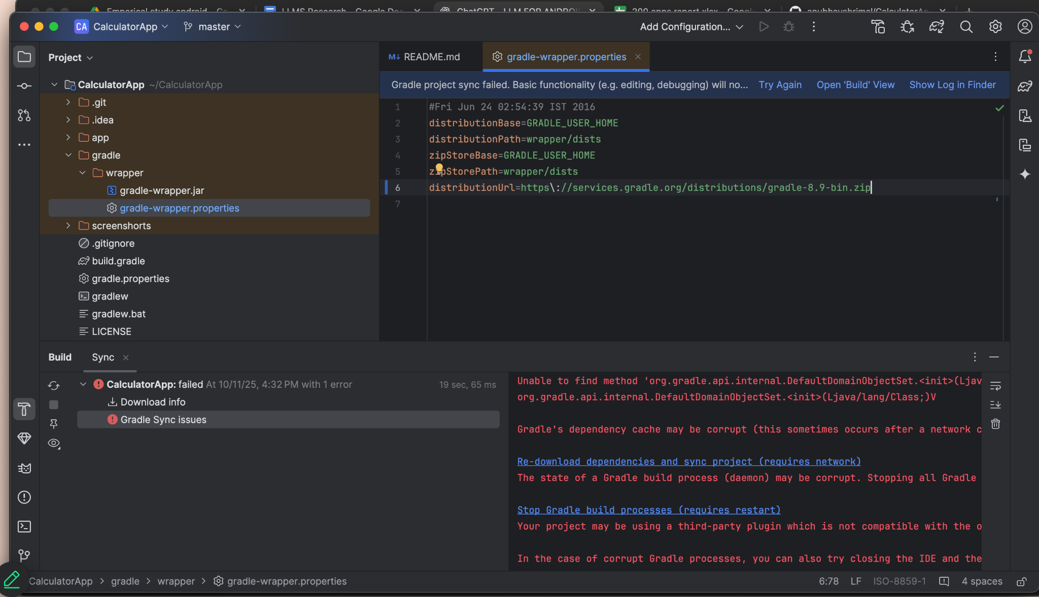

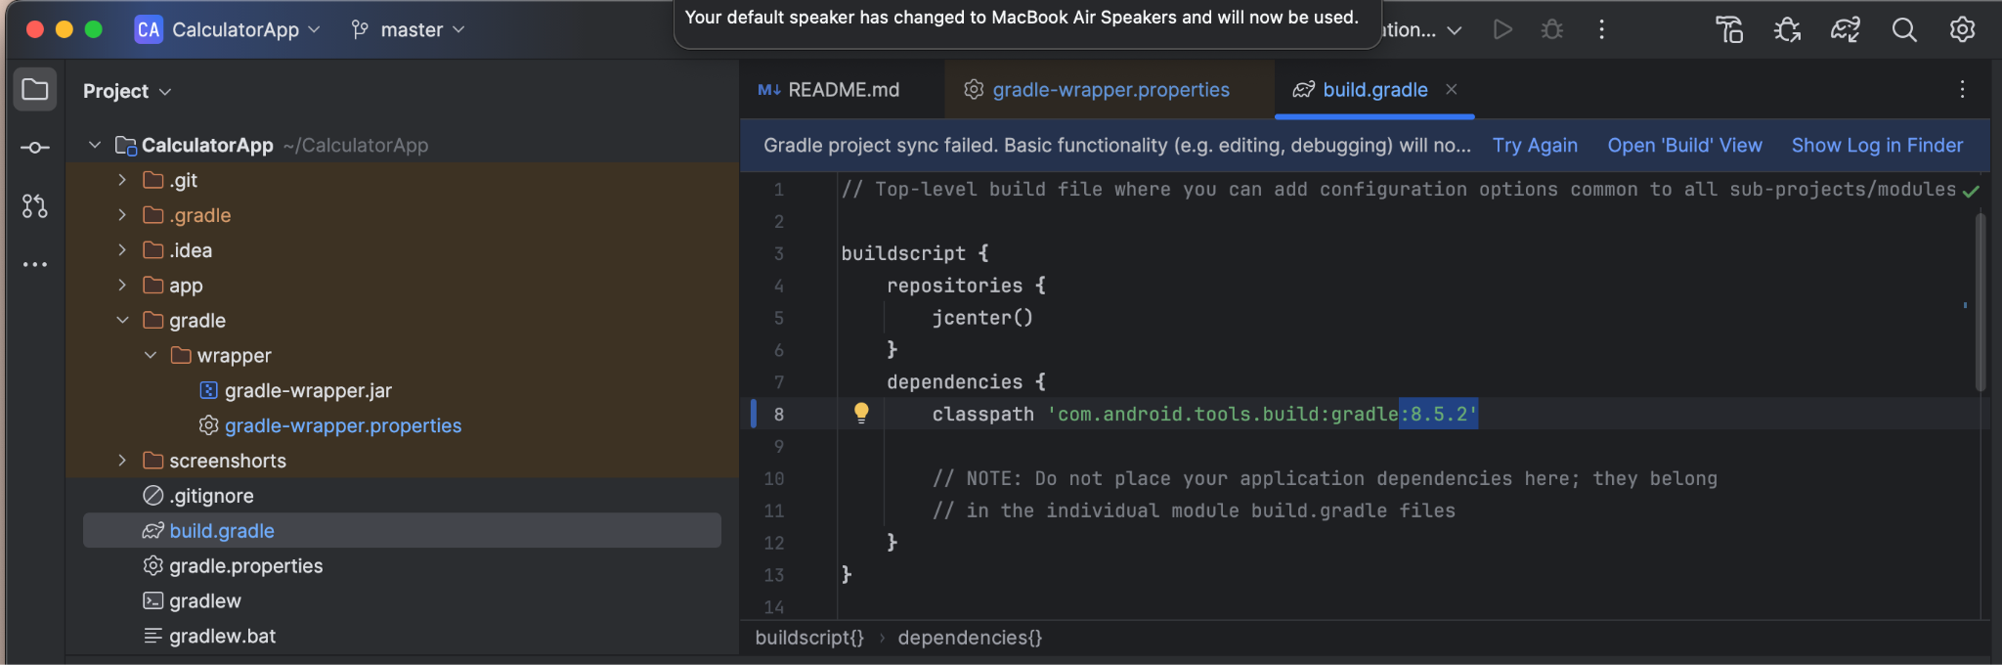

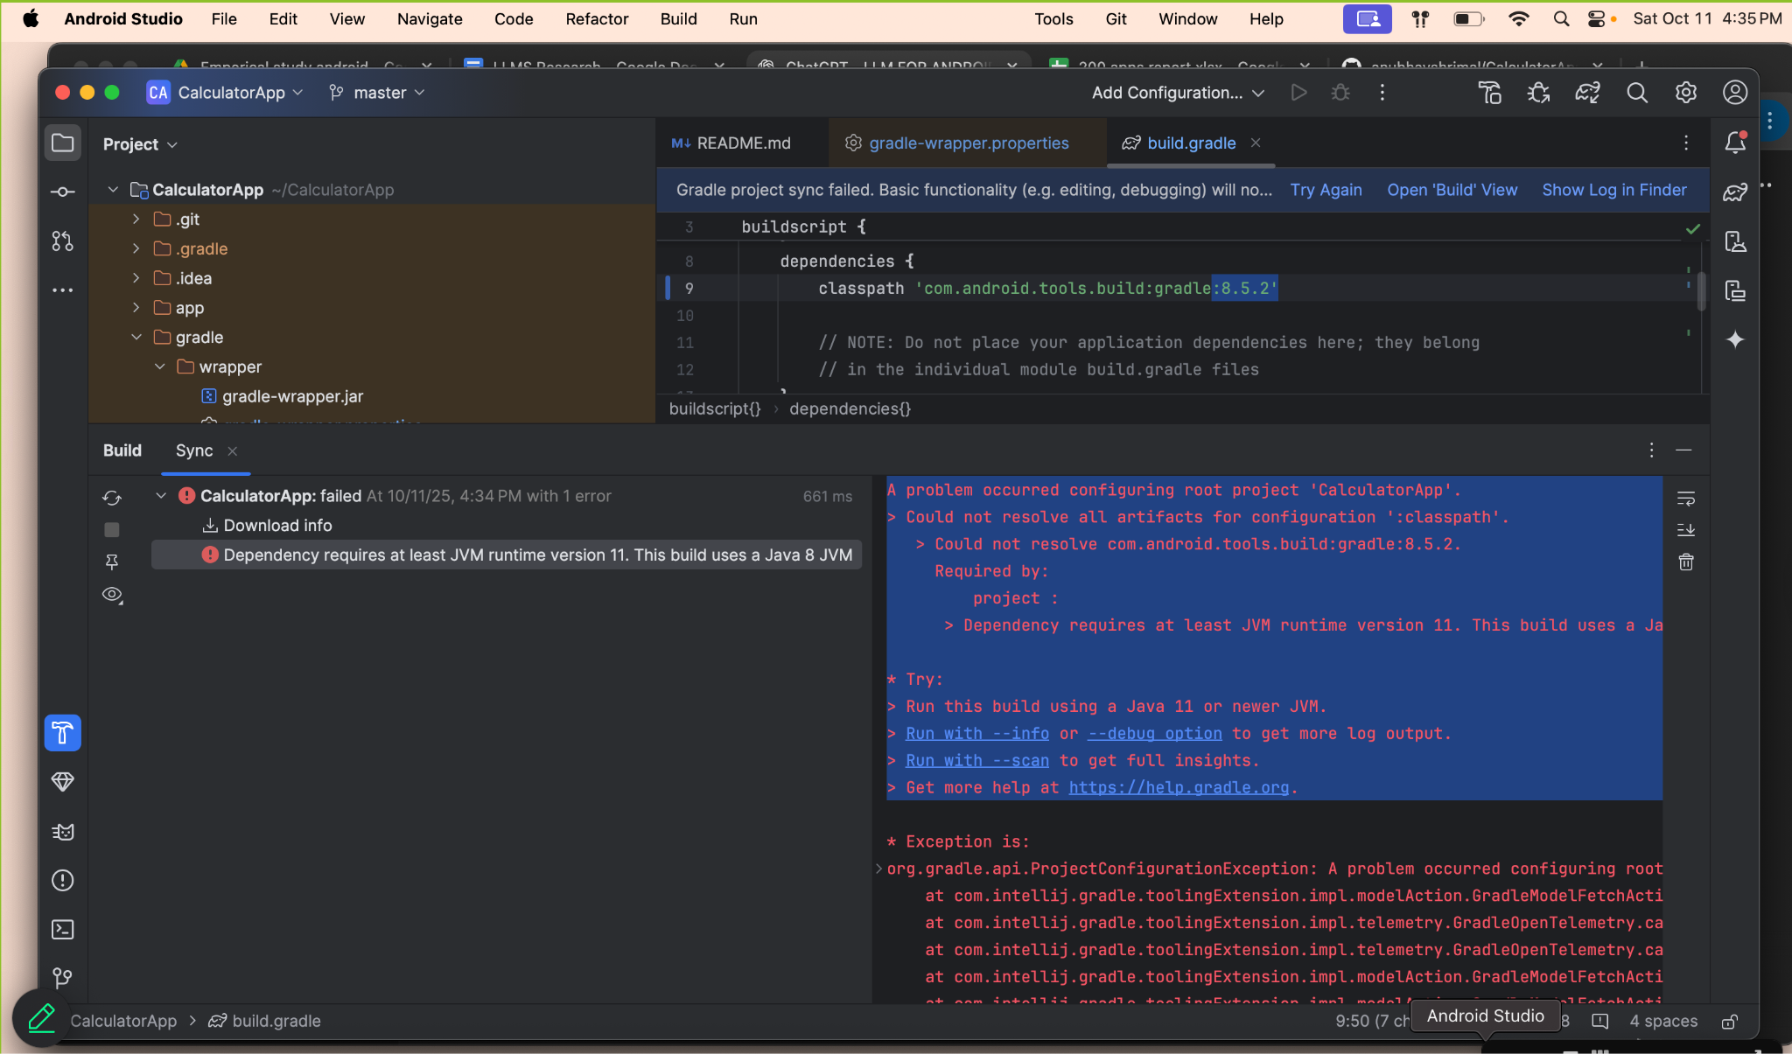

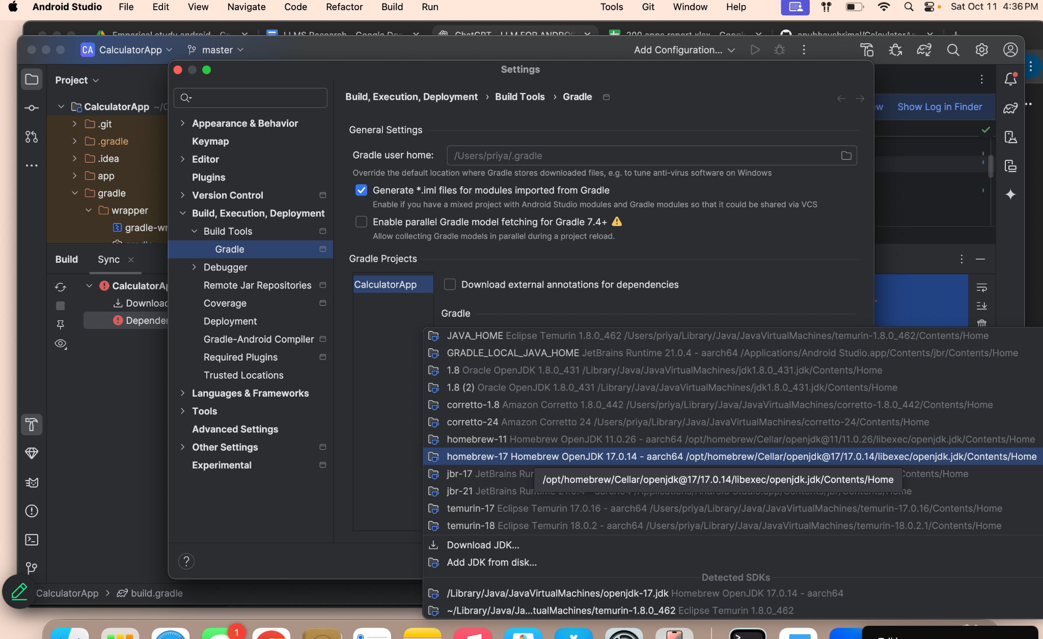

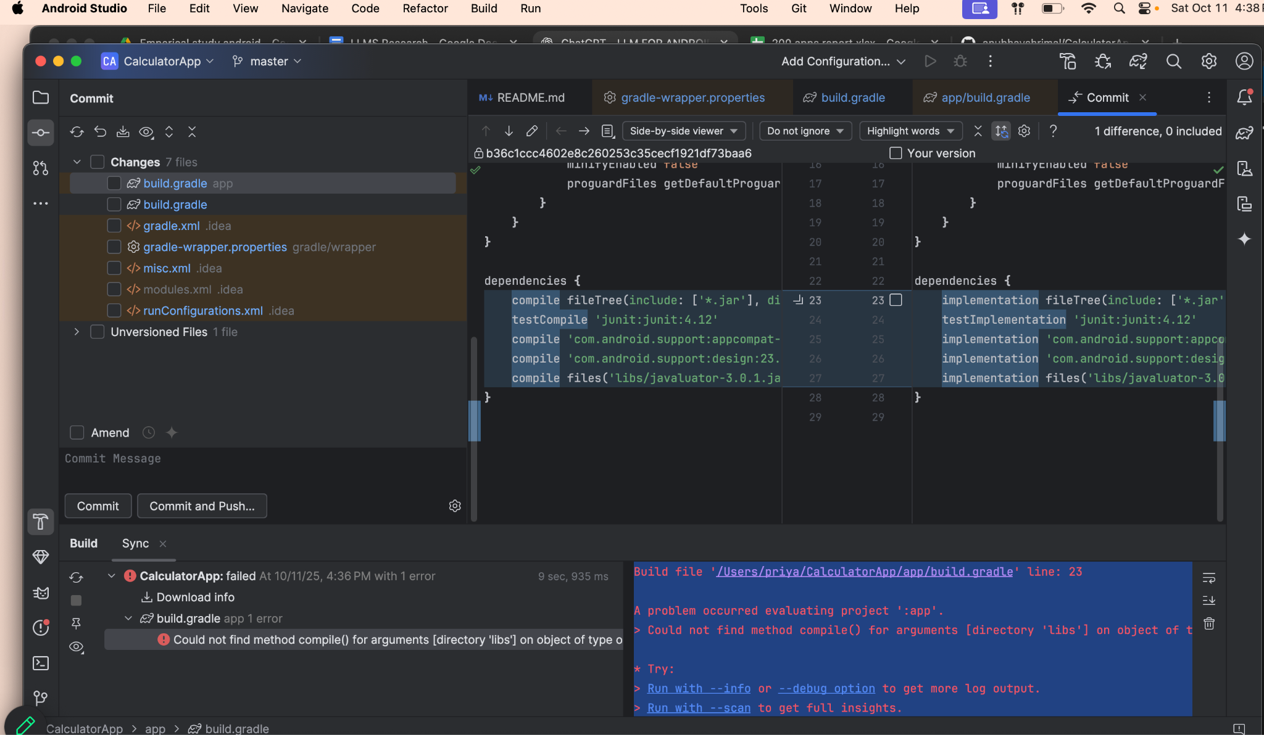

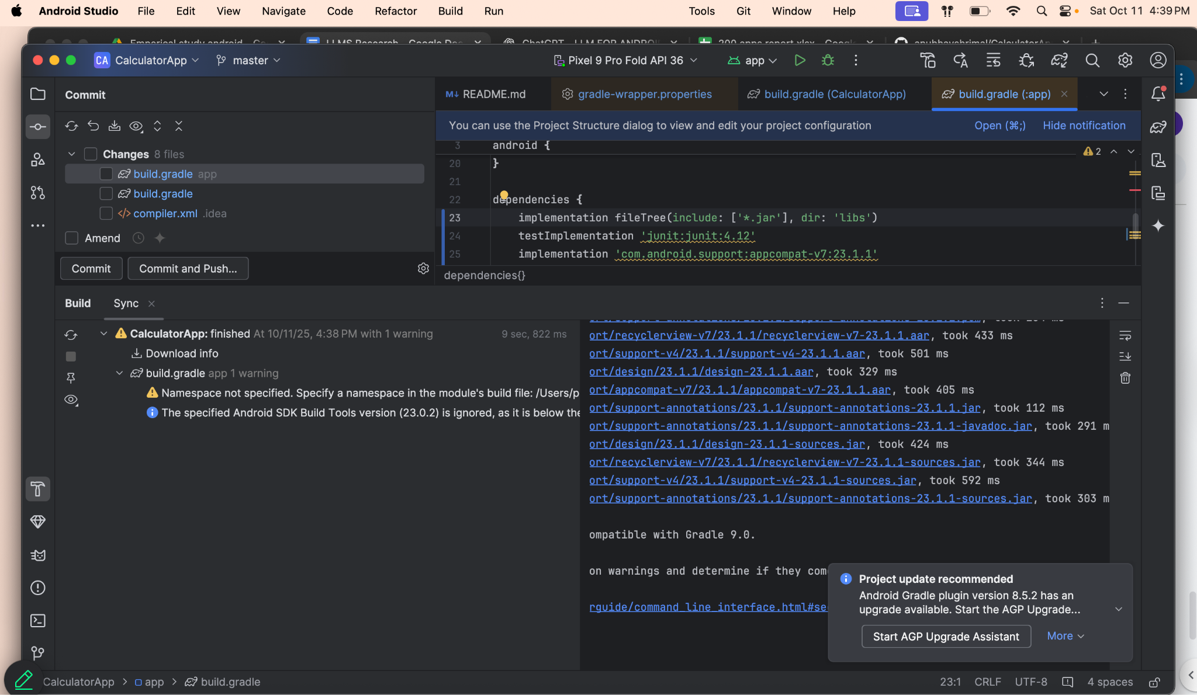

Complied Successfully

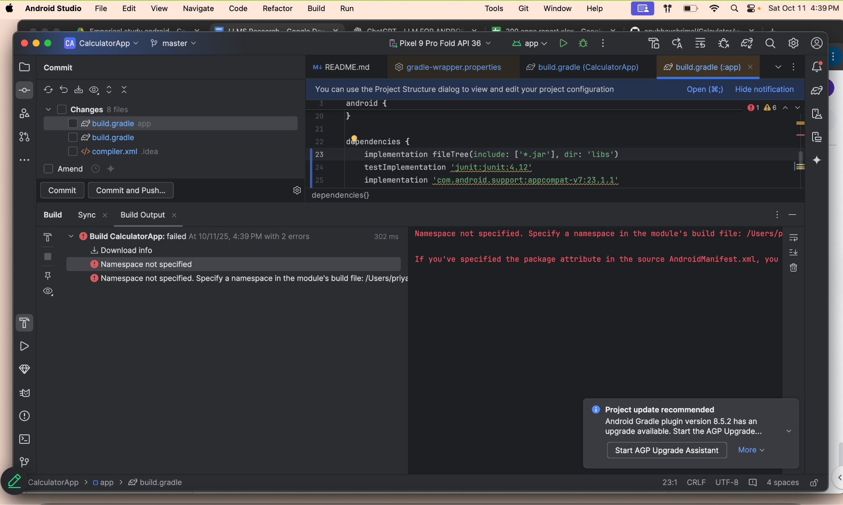

Error while running

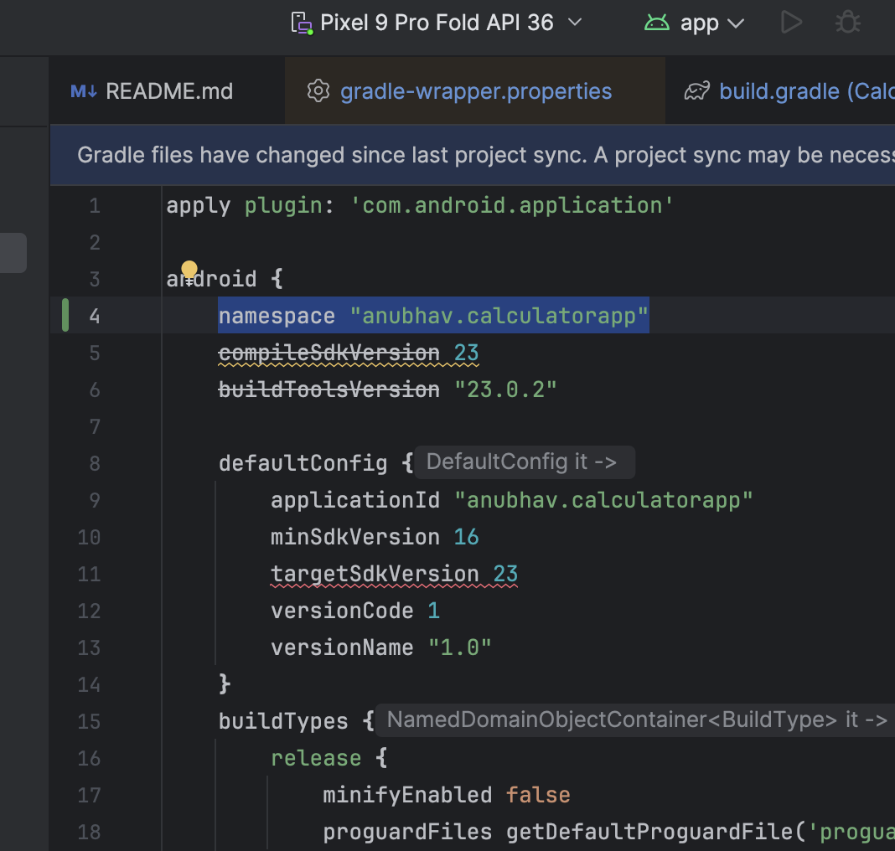

Added Namespace

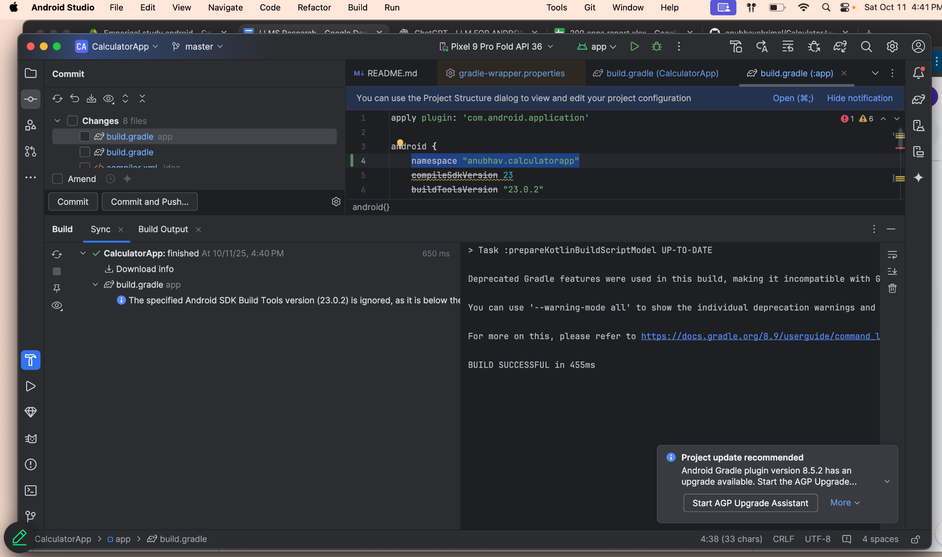

Complied Success

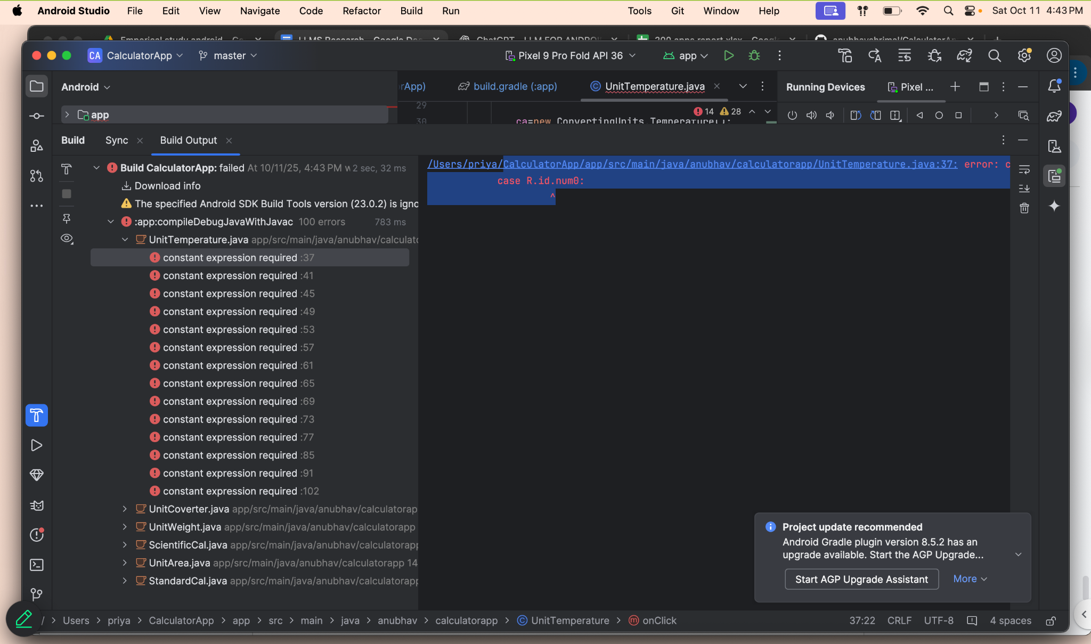

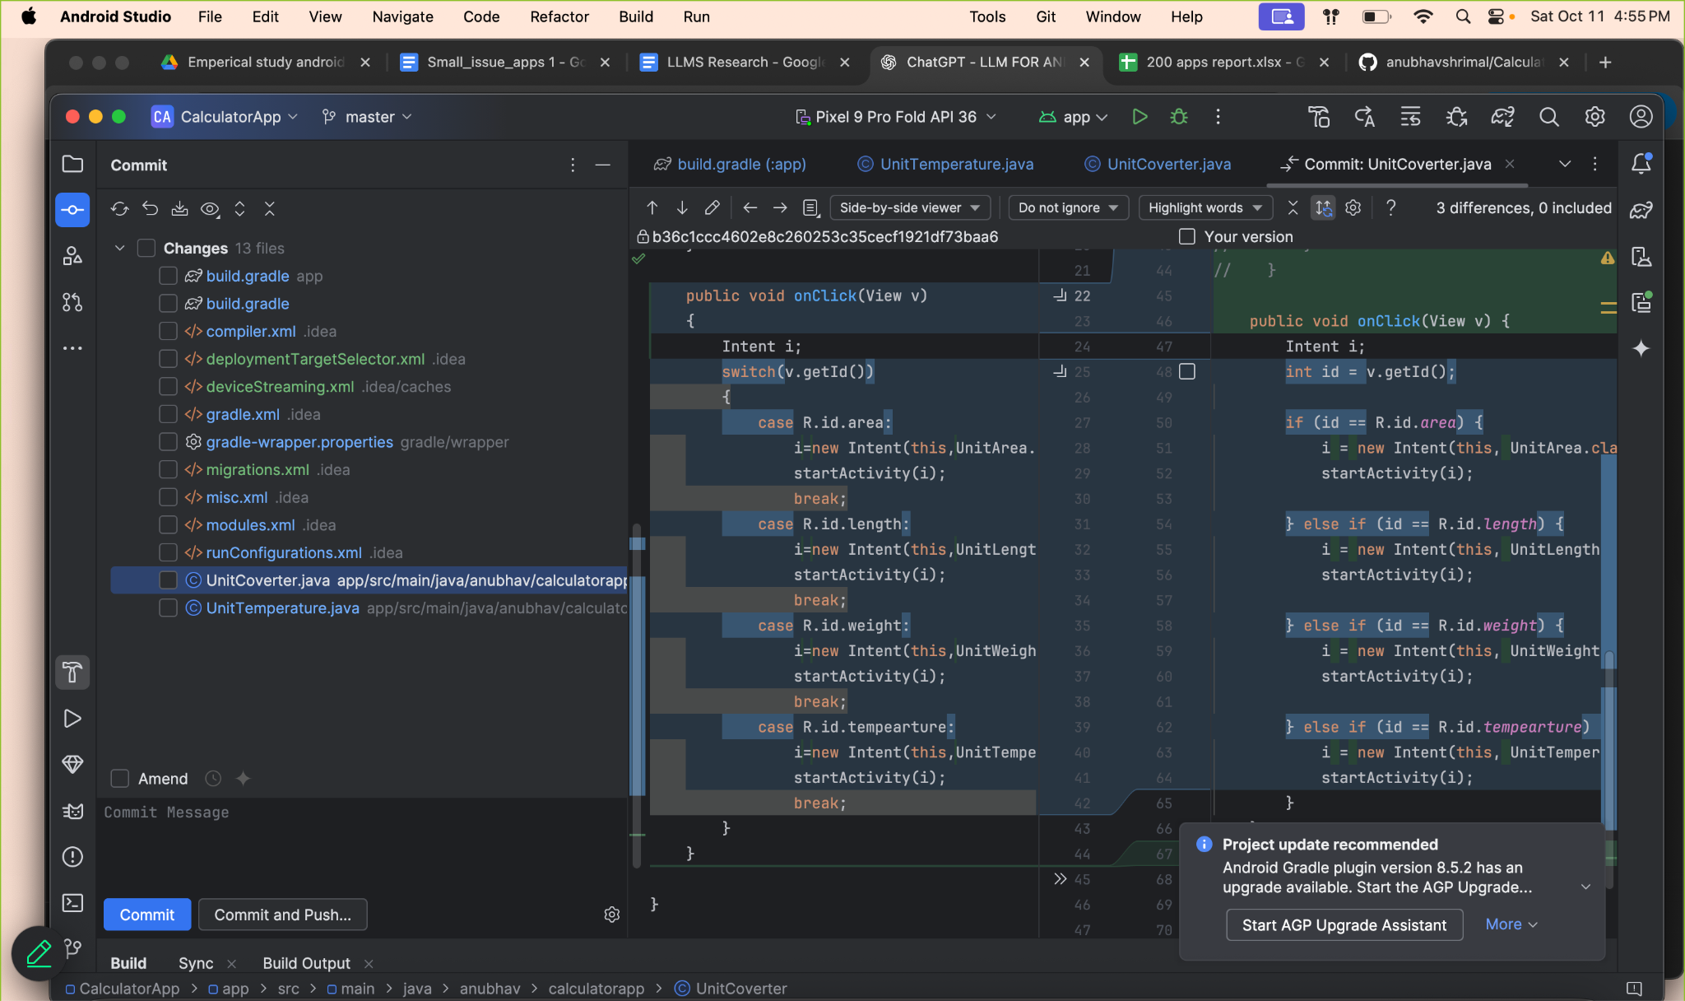

Update Switch conditions to if-else for all this below files :

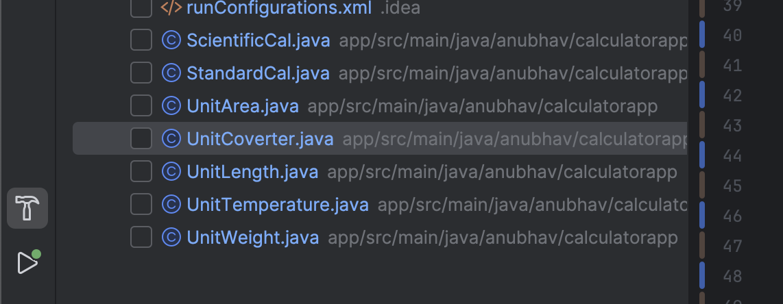

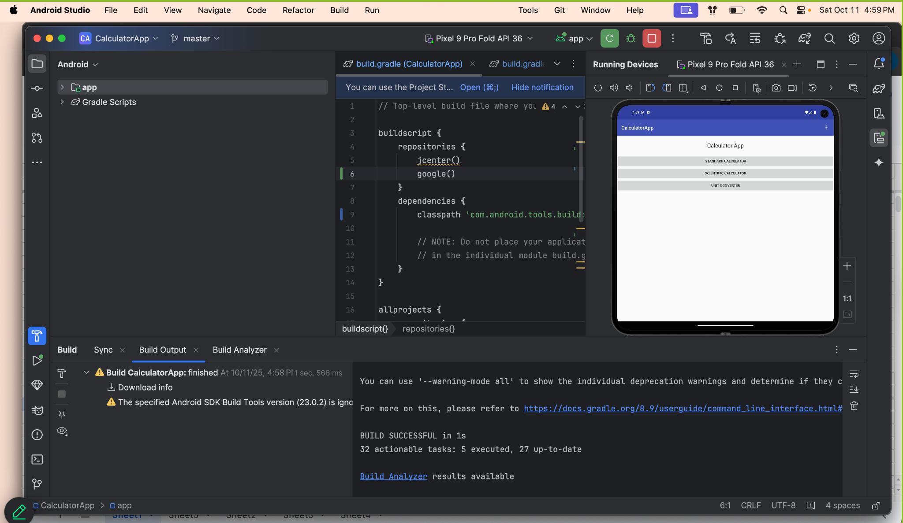

Complied and running Successfully

CHATGPT Link : <https://chatgpt.com/share/68eac562-8e2c-8009-9364-6b2af7ab2314>